DeepSense V2V Beam Tracking — Project Understanding & Background Knowledge
A combined reference: what the project is and why it matters (Part 0), followed by the two technical foundations — wireless/mmWave fundamentals and conformal prediction — needed to understand it (Parts 1–4).

Part 0: Project Understanding
A consolidated reference for what this project is, what it solves, and how to explain it — for your own understanding and for writing the paper's introduction/motivation section.

0.1 What kind of communication is this?
mmWave (millimeter-wave) Vehicle-to-Vehicle (V2V) communication, at 60 GHz — a high-frequency wireless band offering far more bandwidth than today's WiFi, 4G/5G-sub6GHz, or existing V2X standards (DSRC, C-V2X).
The catch: mmWave signals are highly directional and fragile. Unlike WiFi, you can't broadcast omnidirectionally — the transmitter and receiver need narrow, precisely-aimed antenna “beams” pointed at each other, or the link barely works at all.

0.2 Where the 256 beams come from (verified against official testbed docs)
- Unit1 (receiver vehicle) carries four 60 GHz phased-array antenna modules, physically mounted facing front, back, left, and right on the vehicle roof.
- Each of the 4 arrays is a 16-element phased array, using a fixed codebook of 64 pre-computed beam-steering directions — electronically steered (no moving parts), not physically rotated.
- 4 physical panels × 64 codebook directions = 256 total candidate beams. This is exactly pwr1–pwr4 in the dataset.
- Unit2 (target/transmitter vehicle) transmits with a simple quasi-omni antenna always pointed at the receiver — it doesn't beam-steer. Only the receiver (unit1) needs to search for the right beam. This project solves receive-beam selection, not a joint transmit+receive search.
This matches what the EDA found empirically (bearing-clustering per pwr1-4 in Cell 7) — good independent confirmation.

0.3 What's the testbed, and is this in real cars?
“Testbed” = the whole research system, not a single device. It's the combination of hardware, mounting/calibration fixtures, synchronization software, and two instrumented vehicles used to collect the data — not one box you could point at.
Devices inside the testbed (DeepSense Testbed #6):
Modality | Device
mmWave comms | Sivers Semiconductors 60 GHz phased-array transceiver, 16-element ULA receiver, quasi-omni transmitter
GPS | GPS-RTK receiver, sub-10cm accuracy, 10 Hz
Camera | ZED2 RGB stereo camera, 110° FoV, 1920×1080 @ 30fps
LiDAR (unused in this project) | Ouster OS1-32, 32-vertical/1024-horizontal channels, 120m range
Radar (unused in this project) | TI AWR2243BOOST FMCW, 76–81 GHz

This is research instrumentation, not production automotive hardware. No consumer or production vehicle has this today. Real vehicles currently use lower-frequency V2X (DSRC/C-V2X, 5.9 GHz) if they have any direct V2V link at all. This is forward-looking 6G research, years ahead of deployment.
Vehicle powertrain (EV vs. petrol/diesel): not documented in any source checked — genuinely unknown, and not physically relevant to the problem (mmWave propagation and GPS/camera prediction don't depend on the drivetrain).

0.4 What is the target variable?
Two related targets, matching the B1/B3 (classification) and P1/P3 (profile) model split:
- Classification target: unit1_overall-beam — an integer 0–255, the single beam (out of 256) with the strongest received power at that moment. Verified directly: overall-beam = argmax(concat(pwr1, pwr2, pwr3, pwr4)).
- Profile/regression target (P3): the full 256-length power vector itself (converted to dB) — not just the winner, but how strong every beam would be. This is what lets you measure “how close were the runner-ups,” which is what the near-optimal-set-size / Δ-dB tolerance analysis in the EDA was built around.

0.5 The actual problem being solved — precise statement
Primary problem: beam-search latency and overhead.
Finding the right beam normally means sweeping through candidate beams one at a time, measuring signal strength at each. For two vehicles moving at speed, this sweep is too slow — by the time it finishes, the vehicles have moved and the best beam has changed. This causes:
- High latency before a usable link exists
- Wasted time/bandwidth spent searching instead of transmitting data
- Dropped or unreliable links because the search can't keep pace with vehicle motion
What better accuracy does about it: predicting the right beam directly from GPS + camera (skipping most of the sweep) shortens beam-acquisition time and cuts search overhead. This is a latency/efficiency problem, not a broader traffic-safety or bandwidth-shortage problem.
Secondary problem: no reliability guarantee on a raw prediction.
A plain “predict the best beam” model gives a guess with no sense of how confident it is. This project's added piece — online conformal risk control (Gibbs & Candès-style adaptive quantile tracking) — solves a second, more specific problem: giving a statistically bounded guarantee on how often the true best beam is missed, adapting that guarantee in real time as conditions change while driving (open road vs. near-blockage, short-range vs. long-range). This is a trust/reliability problem, distinct from raw accuracy.
One-sentence version for the paper:
“This project addresses the beam-acquisition latency and reliability problem in mmWave V2V communication — the time and overhead cost of finding the correct antenna beam direction for a fast-moving vehicle pair — by predicting it from GPS and camera sensing instead of exhaustive beam sweeping, with a statistically calibrated reliability guarantee on that prediction.”

0.6 What better accuracy actually enables
Better/faster beam acquisition is the technical roadblock currently standing in front of these driver-facing applications — it doesn't implement them itself, but removes the blocker that prevents them from being technically feasible:
- Cooperative perception (“see-through” vision): a car ahead can share live camera/LiDAR data with your car over this link, letting your car detect a hazard two vehicles ahead before your own sensors could. Needs high bandwidth + low latency — exactly what fast beam acquisition enables and slow sweeping breaks.
- Instant hard-braking / collision alerts: millisecond-scale direct vehicle-to-vehicle warnings, faster than human reaction time — only useful if the link is already up and fast.
- Platooning: vehicles drafting closely together need continuous, low-latency coordination; a link that keeps dropping due to slow beam reacquisition makes this unsafe.
- High-bandwidth local updates: detailed, instant road/hazard data passed vehicle-to-vehicle, richer than what a cellular connection could deliver in the same instant.

0.7 Who this actually serves (the honest chain, not compressed)
- Telecom/wireless research community & 6G standards bodies — most direct beneficiary; this is exactly the kind of work that incrementally informs future 3GPP/IEEE V2X standards.
- mmWave hardware/chipset vendors (e.g. Sivers Semiconductors, the maker of the actual device used here) — would eventually implement techniques like this in commercial modules.
- Automotive Tier-1 suppliers / car companies — downstream customers of that hardware/software stack, if they adopt mmWave V2X.
- Drivers/consumers — the furthest downstream, most indirect beneficiary; would only ever experience this as an invisible efficiency improvement inside a future connected-vehicle feature.
Avoid overclaiming: this doesn't reduce accidents, congestion, or emissions directly, and doesn't relieve any bandwidth problem consumers have today (mmWave V2V isn't deployed anywhere real yet). The honest, defensible claim is narrow: it improves the efficiency and reliability of the beam-acquisition step within a future mmWave V2V system — a necessary but not sufficient enabling component for applications that don't yet exist in deployed form.

0.8 Why this project is worth doing even without guaranteed deployment
- It targets a real, currently-open research question, evidenced by your own literature review (Mollah et al. 2025, SCAN-BEST, CLBP, AMBER — all 2025/2026 papers). Your specific angle — full power-profile prediction plus online trajectory-adaptive risk control, rather than a fixed Top-k candidate set — is an identifiable, citable gap.
- This is how foundational communications research normally works. 5G's beam-management standards trace back to years of academic papers like this, absorbed gradually by standards bodies — no single paper “gets deployed” on its own; each contributes to a slow accumulation.
- The methodology has value independent of the V2V application. Online conformal risk control is a general real-time uncertainty-calibration tool, applicable well beyond beam prediction (any streaming prediction problem under distribution drift). Demonstrating it works on real, physically-grounded trajectory data is a legitimate result on its own.
- Your supervisor's actual bar is rigor and publishability, not deployment — a well-evidenced, honestly-scoped paper that correctly identifies and fills a real gap is a complete, successful outcome.

0.9 Quick-reference summary table
Question | Answer
Communication type | mmWave (60 GHz) V2V
Why it's hard | Narrow directional beams; sweeping is too slow for moving vehicles
Target variable | overall-beam (0–255 classification) + full 256-beam dB power profile (regression)
Direct problem solved | Beam-acquisition latency & search overhead
Secondary problem solved | Lack of a calibrated reliability guarantee on predictions
Enables (not yet deployed) | Cooperative perception, instant collision alerts, platooning, high-bandwidth local updates
Deployed in real cars today? | No — research testbed hardware only
Direct beneficiary | Telecom/6G research community, hardware vendors
Indirect, future beneficiary | Automakers, then drivers
Why it's worth doing regardless | Real open research gap, standard research-to-standards pathway, generalizable methodology, meets supervisor's rigor/publication bar

Part 1: Wireless / mmWave Fundamentals
Purpose: the two topics most people with a general ML background won't already have, but which are load-bearing for the DeepSense beam-tracking project. This is deliberately “just enough,” not a full course — read this before Phase 1, and revisit Part 2 again before you implement Phase 6–7.

1.1 The physical problem
At 60 GHz (millimeter-wave, or mmWave), signals travel in almost a straight line and lose a lot of energy over distance. The standard fix is beamforming: instead of broadcasting in every direction, the antenna array focuses energy into a narrow beam pointed at the other vehicle — much stronger signal, but only if you're pointed the right way.

1.2 Why this is hard for V2V
With a 64-beam codebook — and this dataset stacks four such codebooks together into 256 total candidate directions — the receiver doesn't inherently know which direction is best. The traditional way to find out is beam sweeping: try beam 1, measure the received power, try beam 2, measure again, and so on through all 256 directions. That sweep costs time and overhead, and because both vehicles are moving, the best beam keeps changing — so you can't just sweep once and be done.
This overhead is the entire motivation for the project: if synchronized RGB and GPS can predict which beams are likely good before sweeping, you only need to probe a small candidate set instead of all 256.

1.3 Key terms you'll see throughout the project
- Received power / RSSI — how strong the signal is at a given beam; measured in dBm.
- Power gap (d_b) — how far a given beam's power is from the best beam's power, in dB. This is the project's core prediction target.
- Line-of-sight (LOS) vs. non-line-of-sight (NLOS) — whether there's a clear path between vehicles or the signal has to bounce/diffract around obstacles; strongly affects how “peaky” or “spread out” the beam-power profile looks.
- Beam training / beam sweep — the brute-force process of testing every beam; this is the overhead the project is trying to reduce.
- dB (decibel) intuition — power is measured on a logarithmic scale. Roughly: +3 dB ≈ doubling the power, −3 dB ≈ halving it. This is why the project's tolerance thresholds (Δ ∈ {1, 3} dB) are meaningful physical choices, not arbitrary numbers — a 1 dB tolerance is a tight, near-optimal requirement; 3 dB is a noticeably looser one.

1.4 The picture
Imagine the receiver vehicle's antenna array as fanning out several candidate beam directions toward the transmitter vehicle. Only one of those directions — the one that actually points at the transmitter — gives strong received power. Everything else is a “sweep” through directions that mostly miss. The project's job is to look at the receiver's camera images and GPS position and predict, in advance, roughly which direction (or small set of directions) is worth checking — instead of blindly sweeping through all 256.
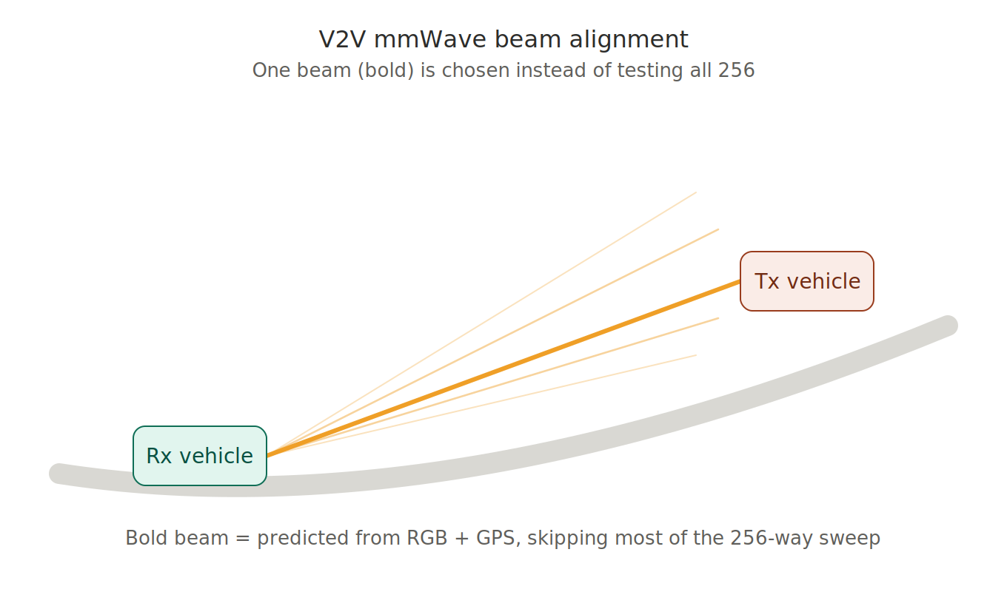

Part 2: Conformal Prediction

2.1 The core idea
A model can score how “good” it thinks each beam is, but that score alone doesn't tell you how reliable it is. Conformal prediction fixes this with a simple, distribution-free trick: instead of trusting the model's raw confidence, you calibrate a threshold using a held-out set of examples where you already know the right answer, and use that threshold to build a candidate set with an empirically guaranteed reliability rate — no assumptions about the underlying probability distribution needed.

2.2 The static calibration mechanic
- Take a calibration set (data the model didn't train on).
- For each example, compute a nonconformity score — in this project, this is exactly the power gap d_b: how far a beam's power is from the best one.
- Sort all these scores and pick the value at your target quantile (say, the 90th percentile) — call it q.
- On new data, build the candidate set as “every beam whose predicted gap is ≤ q.” Because q was calibrated on real outcomes, this set is empirically guaranteed to include the near-optimal beam roughly 90% of the time.
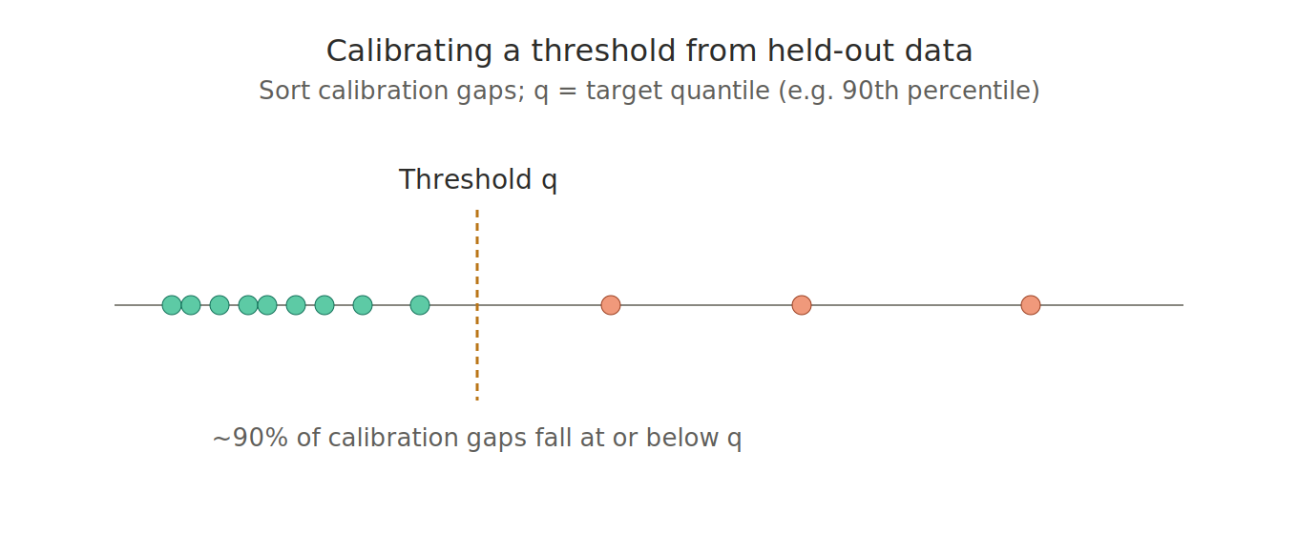
The catch: this guarantee depends on an assumption called exchangeability — roughly, that the calibration data and the future test data come from the same, unchanging distribution. That assumption is fragile here: the car is driving. Lighting changes from day to night, the route changes, buildings and traffic create different blockage patterns. A threshold calibrated once at the start of a trip can go stale as conditions drift.

2.3 The online twist: adapting the threshold as you drive
Instead of calibrating q once and freezing it, an online controller updates q after every single decision, using a feedback rule:
- If the actual best beam was missed (outside the candidate set by more than tolerance Δ), raise q — make the candidate set more inclusive next time.
- If it was not missed, shrink q slightly — keep the candidate set (and the probing cost) as small as possible.
This is a real, named method — Adaptive Conformal Inference (Gibbs & Candès, NeurIPS, 2021) — not something invented for this project. It trades the strict, finite-sample guarantee of static conformal prediction for a looser but more honest one: the miss rate stays close to the target, on average, over the long run, even as conditions keep changing. A stronger variant with proportional/integral/derivative-style correction terms is Conformal PID Control (Angelopoulos, Candès & Tibshirani, NeurIPS, 2023) — this project's stretch-tier controller.
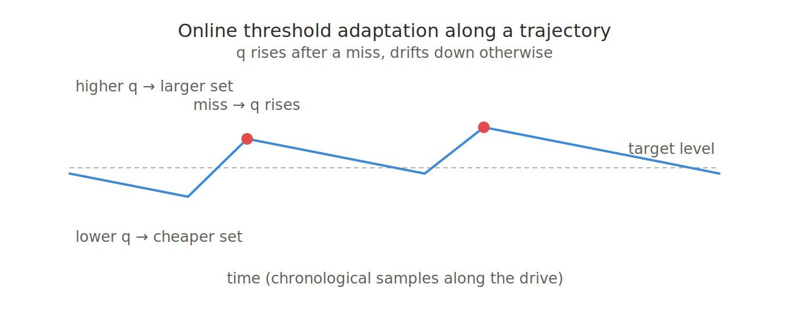

2.4 Why the distinction matters
Static conformal prediction promises “this set contains the near-optimal beam ~90% of the time” assuming exchangeability — a promise that gets shaky once the vehicle starts driving through changing conditions. The online controller trades that crisp promise for a weaker, more honest one: “averaged over the whole drive, the miss rate tracks 90%, even if it wobbles sample to sample.” Knowing the difference between these two claims — and never accidentally implying the stronger one when you've only earned the weaker one — is exactly what makes a conformal-methods methodology section hold up under scrutiny (see Section 5a of the project blueprint, “Guarantee and Claim Discipline”).

Part 3: Mapping the Concepts Directly onto the Project
Concept | What it is in this project
Nonconformity score | The predicted power gap d̂_{t,b} — how far each beam is from the model's predicted best
Candidate set C_t(q) | All beams with d̂_{t,b} ≤ q — this is what gets probed instead of all 256
Miss loss ℓ_t | 1 if none of the candidates actually got within Δ dB of the true best beam
Target risk α | The miss rate you're willing to tolerate (e.g. 10%)
Static calibration (Blueprint Phase 6) | Set q once from the calibration block — standard conformal risk control
Online controller (Blueprint Phase 7) | Update q after every sample as the vehicle drives — Adaptive Conformal Inference / Conformal PID Control

Part 4: What This Covers, and What It Doesn't
This document gives you the two pillars that are genuinely unfamiliar to most people with an ML background — wireless beam management and conformal prediction — plus the project-understanding context in Part 0. It is not the complete background you need. Two more things are still worth deliberate study before or during the relevant build phases:
- Core deep learning architecture literacy — CNNs for the RGB branch, GRU/Transformer encoders for the temporal GPS+image sequence, and multi-task heads (classification + regression together, the P3 model in the blueprint). Worth an hour of review before Phase 4–5 if concepts like “why a shared backbone with two output heads helps” feel fuzzy.
- Time-series evaluation discipline — the distinction between leakage (overlapping frames from the same trajectory spanning train/test) and exchangeability (why conformal guarantees can break under trajectory dependence even without leakage) is a common point of confusion, and the two are genuinely different problems. This also covers why block bootstrap resamples whole trajectories rather than individual frames.
Everything else — specific fusion architecture choices, the PID-controller variant's control-theory details, deeper bootstrap/statistical mechanics — is reasonable to learn on demand while implementing the corresponding blueprint phase, rather than needing to be front-loaded now.

Part 5: Related Paper Reviews
Three papers, chosen because each one either defines the exact dataset this project uses or uses the exact same DeepSense 6G Scenarios 36–39 (the identical V2V trajectories this project's blueprint is built on) — not just DeepSense in general, which spans many unrelated V2I and ISAC scenarios. Reviewed in the order you should read them: the dataset itself, then a GPS-only baseline, then a multi-modal fusion baseline that extends it.

5.1 The dataset paper itself
Morais, J., Charan, G., Srinivas, N., & Alkhateeb, A. “DeepSense-V2V: A Vehicle-to-Vehicle Multi-Modal Sensing, Localization, and Communications Dataset.” IEEE Transactions on Vehicular Technology, 2025 (arXiv:2406.17908).
What it is: the official paper introducing the dataset this project uses. It describes the two-vehicle testbed — a 360° camera, four radars, four 60 GHz phased arrays, a 3D LiDAR, and two precise RTK-GPS units — and the resulting drives: 120 km total, in both day and night conditions, across intercity and rural settings, at speeds up to 100 km/h.
Why it matters for you: this is the paper to cite for the dataset itself, and the one that grounds every claim in Part 0 of this document (the four-phased-array layout, the 256-beam codebook structure, the quasi-omni transmitter). It doesn't propose a beam-prediction model — it's infrastructure, not a competitor — so there's nothing here to differentiate your novelty claim against. Read it once to confirm your understanding of the raw data matches the source, then move on to the two papers below for the actual modeling comparisons.

5.2 GPS-only baseline on the exact same scenarios
Mollah, M. B., Wang, H., & Fang, H. “Position Aware 60 GHz mmWave Beamforming for V2V Communications Utilizing Deep Learning.” 2024 IEEE International Conference on Communications (ICC), pp. 4711–4716 (arXiv:2402.01259).
What it does: predicts a top-M candidate beam set using only GPS position — no camera, no LiDAR — via a 1D-CNN over normalized (latitude, longitude) sequences, trained with cross-entropy against the ground-truth best-beam index. Confirmed to use exactly Scenarios 36 (24,800 samples), 37 (31,000), 38 (36,000), and 39 (20,400) — the same four V2V scenarios this project's blueprint is built on, with the same per-scenario sample counts already cited in the project blueprint.
Results: for top-1 prediction in Scenario 36, roughly 19.67 percentage points higher accuracy than a location-fingerprinting baseline; up to 84.58% average received-power ratio at top-1, tested with M ∈ {1, 5, 9, 13}.
Why it matters for you: this is the closest published thing to your project's B1 (GPS-only) baseline — same scenarios, same GPS-normalization approach, same top-M framing. It stops at a fixed-size candidate set (no full power-profile prediction, no conformal risk control, no online adaptation), which is exactly the gap your V3 blueprint fills. Worth citing by name in your related-work section as the GPS-only precedent, and worth comparing your own B1 baseline's numbers against this paper's reported accuracy/power-ratio figures as a sanity check that your reimplementation is in the right range.

5.3 Multi-modal fusion baseline, extended journal version
Mollah, M. B., Wang, H., Karim, M. A., & Fang, H. “Multi-Modality Sensing in mmWave Beamforming for Connected Vehicles Using Deep Learning.” IEEE Transactions on Cognitive Communications and Networking, 2025 (arXiv:2504.06173).
What it does: the journal-length extension of the paper above, from the same first author, now fusing position + visual (EfficientNet-B0) + LiDAR (PointNet) via feature concatenation and a shared classification head. Evaluated on both V2I Scenarios 31–34 and V2V Scenarios 36–39 (the same four your project uses), again predicting a top-M beam set with cross-entropy training.
Results: up to 98.19% top-13 accuracy on V2I and 66.96% on V2V (V2V is consistently harder — both vehicles moving, versus one stationary unit in V2I); 98.86% average received-power ratio at top-1 on V2V. The paper also translates this into a standards-relevant number: integrated into the 5G-NR sweep procedure, their predicted top-13 candidate set cuts beam-sweep search space by 79.67% and search time by 91.89% versus full 64-beam exhaustive search.
Why it matters for you: this is the closest published thing to your project's B3/fusion baseline — same scenarios, multi-modal, top-M candidate-set framing — though it fuses LiDAR rather than your project's RGB+GPS-only pairing, and again stops at a fixed top-M set with no full power-profile regression and no conformal calibration. The 5G-NR latency-translation calculation in their Section VI-C (Equations 14–15) is a good template for writing the equivalent overhead-reduction argument in your own results section, once you have final probe-count numbers from your candidate-set and online-controller evaluation (blueprint Phase 8).

